Introduction to Algorithms & Problem-Solving

What are Algorithms?
A systematic approach to solving computational problems efficiently involves breaking down a problem into smaller, manageable steps, structuring them logically, and executing the solution in an organized manner. It starts with understanding the problem, defining inputs and expected outputs, and designing a step-by-step plan using algorithms, flowcharts, or pseudocode. Logical structuring ensures clarity and minimizes errors, while execution involves implementing the solution in code, testing for correctness, and optimizing for efficiency. This method helps in developing scalable and effective solutions to complex problems.
Writing Algorithms with Examples
Problem Statement: Write an algorithm to calculate the factorial of a given number n.
Step-by-Step Algorithm:
1. Start
2. Input a number n
3. Initialize fact = 1
4. For i from 1 to n:
Multiply fact = fact * i
5. Display fact
6. End
Corresponding Python Code:
n = int(input("Enter a number: "))
fact = 1
for i in range(1, n + 1):
fact *= i
print(f"Factorial of {n} is {fact}")

Introduction to Flowcharts and Pseudocode
Flowchart: A flowchart is a graphical representation of an algorithm that uses standardized symbols to illustrate the sequence of operations needed to solve a problem. It visually depicts the flow of logic, making it easier to understand, analyze, and communicate the steps involved in a process. Common symbols in a flowchart include ovals for start and end points, parallelograms for input/output, rectangles for processes, and diamonds for decision-making. Flowcharts help in debugging, optimizing, and documenting algorithms efficiently.
Here’s a simple flowchart to determine if a number is odd or even:
- Start
- Input the number (N)
- Is N % 2 == 0?
  - If Yes: Proceed to step 4
  - If No: Proceed to step 5
- Print "Even"
  - Go to step 6
- Print "Odd"
  - Go to step 6
- End
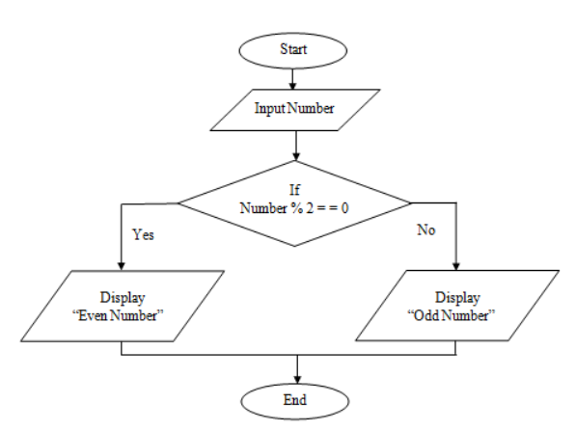
Fibonacci sequence flowchart
- Start
- Input N (number of terms)
- If N ≤ 0, print "Invalid Input" and stop
- Initialize a = 0, b = 1
- Print a and b as the first two terms
- Loop from i = 3 to N
- nextTerm = a + b
- Print nextTerm
- Update values: a = b, b = nextTerm
- End Loop
- End
Pseudocode: Pseudocode is a high-level, informal way of representing an algorithm’s logic without adhering to any specific programming language syntax. It allows programmers to focus on the structure and logic of the solution before translating it into actual code. Pseudocode uses simple, readable statements to describe operations like loops, conditions, and function calls, making it accessible to both technical and non-technical audiences. It serves as a bridge between conceptualizing an algorithm and implementing it in a programming language.
Example pseudocode for Fibonacci sequence:
BEGIN
INPUT n
SET a = 0, b = 1
FOR i FROM 1 TO n DO
PRINT a
SET temp = a + b
SET a = b
SET b = temp
END FOR
END
Python Implementation:
n = int(input("Enter number of terms: "))
a, b = 0, 1
for i in range(n):
print(a, end=' ')
a, b = b, a + b

Problem: Print All Prime Numbers in a Given Range
Write an algorithm and code to print all prime numbers between two numbers, L and R (inclusive). A prime number is a number greater than 1 that has no divisors other than 1 and itself.
Algorithm:
1. Start
2. Input two integers: L and R
3. For i from L to R:
a. If i is less than 2, skip to next i
b. Initialize a flag = True
c. For j from 2 to sqrt(i):
i. If i % j == 0, set flag = False and break
d. If flag is True, print i (it's prime)
4. End
Pseudocode:
BEGIN
INPUT L, R
FOR i FROM L TO R DO
IF i < 2 THEN
CONTINUE
SET isPrime = True
FOR j FROM 2 TO sqrt(i) DO
IF i MOD j == 0 THEN
SET isPrime = False
BREAK
END FOR
IF isPrime THEN
PRINT i
END FOR
END
Python Code:
import math
L = int(input("Enter the starting number: "))
R = int(input("Enter the ending number: "))
print(f"Prime numbers between {L} and {R} are:")
for i in range(L, R + 1):
if i < 2:
continue
is_prime = True
for j in range(2, int(math.sqrt(i)) + 1):
if i % j == 0:
is_prime = False
break
if is_prime:
print(i, end=' ')
Sample Input/Output:
Input:
Enter the starting number: 10
Enter the ending number: 30
Output:
Prime numbers between 10 and 30 are:
11 13 17 19 23 29

